# Configuring Firebase Console Information in Angular Project

## Firebase Account Setup

* Go to <https://firebase.google.com> and sign in with your google account
* Select ‘Go to console’
* Press ‘Create a Project’
* Enter the required information for the project (name, Google Analytics settings, etc.) and then press create project
* Next to your project overview, click on settings and select project settings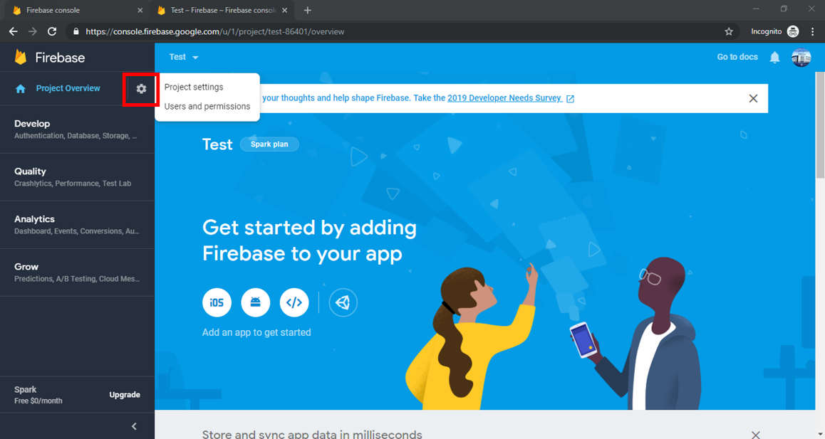
* Scroll to the bottom of the page, and add a web development platform to the project

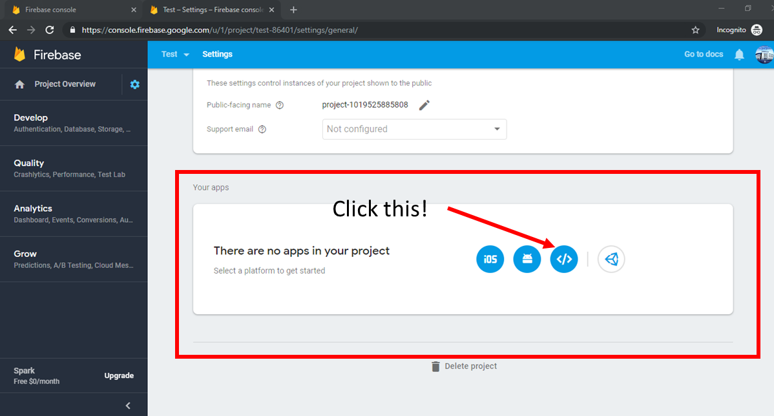

* Enter the App Nickname and press register app, then press continue to console
* Scroll back to the bottom of the settings page. In the ‘Firebase SDK snippet’ section, select Config and copy the code below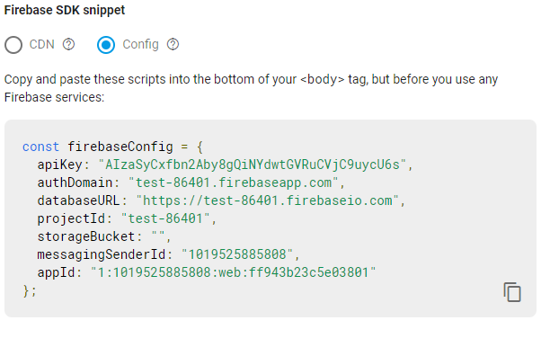

## Entering Config Information into Angular Project

* Under the app source code, in the environment.ts class, paste the firebaseConfig into the file. Do the same in the environment.prod.ts file if you intend on deploying the app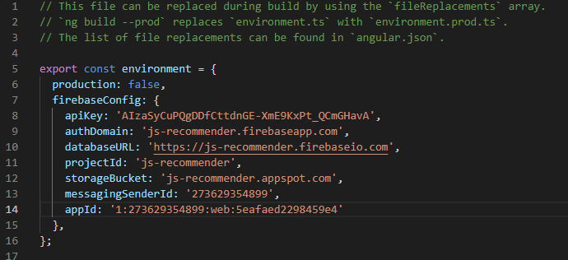

* Go to the *app.module.ts* class. Import the *AngularFireModule* from ‘@angular/fire’. Make sure the angular fire npm package has been installed prior to importing the *AngularFireModule*
* Add this to the imports in your *app.module.ts* class